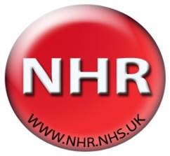
The NHR steering group overseas and guides all activities of the NHR. It has a broad membership giving all stakeholders an input into the running of the registry. Stakeholders include clinicians, commissioners, patient societies, patient representation and the Department of Health.
Jo Howard | Consultant Haematologist
Marilyn Harewood | Consultant Haematologist
Mary Petrou | UK Thalassaemia Society
John James | Sickle Cell Society
Cathy Coppinger | Screening Programme
Sara Trompeter | Consultant Haematologist and Paediatric Haematologist
Anne Yardumian | Consultant Haematologist
Claire Foreman | Commissioner
Rob Hollingsworth | Medical Data Solutions and Services

